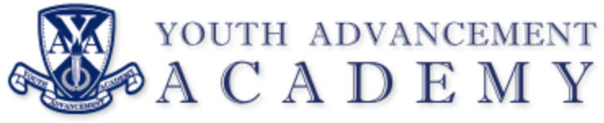

REGULAR BOARD MEETING
Chime School
Kalamazoo, MI 49009
Tuesday, November 14, 2023
5:30 PM

REGULAR MEETING AGENDA

- Call to Order Regular Meeting

- Pledge of Allegiance

- Roll Call

- Approval of Agenda

- Call to the Audience – Audience may address the Board (five minute maximum)

- Approval of Minutes
October 10, 2023, Regular Meeting

- Communications
Director’s Report – Ms. Stacey Smith

- Regular Agenda
A. Financial Report: Dr. Hamlin
B. School Facilities Update: Todd Mora
C. Fall 2023 Board Policy Updates: 1st Reading
C. ACTION: Board Attorney Attendance at Meetings

- Adjournment

Next Meeting: December 12, 2023 (Chime School)

